Name: Mushtaque Ali Khaskheli
Section: H
Assignment: PF lab2

Activity: 01
Write a program that takes 3 values from user. Two values of integer and one value of float data type. Print each result on one line.

INPUT

#include <iostream>
using namespace std;
int main ()
{
int a, b;
float c;

cout<<"Enter an integer number"<<endl;
cin>>a;

cout<<"Enter another integer number"<<endl;
cin>>b;

cout<<"Enter a decimal number"<<endl;
cin>>c;

cout<<a<<" and "<<b<<" are integers and "<<c<<" is a decimal number";

return 0;
}

OUTPUT

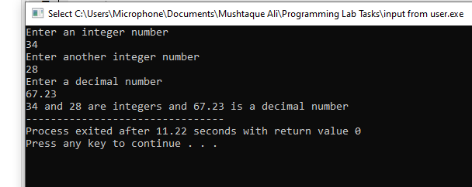

Activity: 02
Write a program that inputs a five-digit integer, separates the integer into its Individual digits and prints the digits vertically.
INPUT

#include <iostream>
using namespace std;
int main ()
{
int num;
cout<<"Enter a six-digit integer number"<<endl;
cin>>num;

cout<<"\t\t"<<num%10<<endl;
cout<<"\t\t"<<num%100/10<<endl;
cout<<"\t\t"<<num%1000/100<<endl;
cout<<"\t\t"<<num%10000/1000<<endl;
cout<<"\t\t"<<num%100000/10000<<endl;
cout<<"\t\t"<<num%1000000/100000<<endl;

return 0;
}

OUTPUT

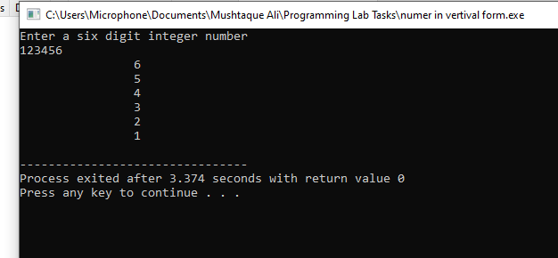

Activity: 03
Make a program where it is asked form user to enter total amount, you have to answer how much ZAKAT to be paid on that amount. ZAKAT is the 2.5% of the total amount

INPUT

#include <iostream>

using namespace std;
int main ()
{
double amount;
cout<<"Enter your Total amount in rupees"<<endl;
cin>>amount;

cout<<"You have to pay "<<2.5/100*amount<<" rupees as Zakat"<<endl;

return 0;
}

OUTPUT
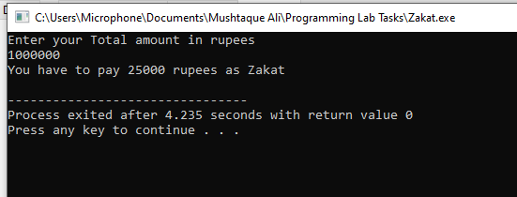.
Activity: 04
4. Write a program to take initial Velocity and acceleration from user, save them in
respective data types and calculate FINAL VELOCITY as per following formula: FINAL
VELOCITY = initial Velocity + acceleration.

INPUT

#include <iostream>
using namespace std;
int main ()
{
float Vi, a, Vf;
cout<<"Enter initial velocity "<<endl;
cin>>Vi;

cout<<"Enter acceleration "<<endl;
cin>>a;

cout<<"\nAsuming that Vf=Vi+a"<<endl;
Vf=Vi + a;
cout<<"So the final velocity will be "<<Vf<<endl;
return 0;
}

OUTPUT

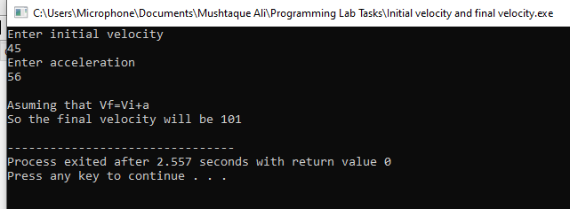

Activity: 05
5. Take distance and time from user, save them in respective data types and calculate
SPEED as per following formula:

INPUT

#include <iostream>
using namespace std;
int main ()
{
float distance, time, speed;
cout<<"Enter distance covered by body in kilometers. "<<endl;
cin>>distance;

cout<<"Enter time taken by body in minutes."<<endl;
cin>>time;

speed = distance/time;
cout<<"The speed of body will be "<<speed<<" km/min."<<endl;

return 0;
}

OUTPUT
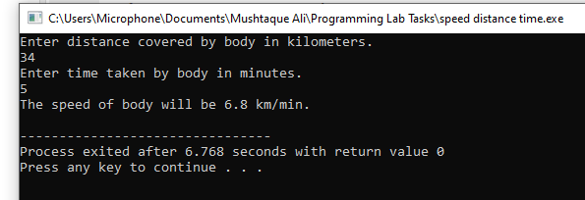

Activity: 06
6. Write a program that finds the value of X by using given formula. Take value of ‘a’ and
‘b’ from user.

INPUT

#include <iostream>
using namespace std;
int main()
{
float a,b,x;
cout<<"The given equation is"<<" x = 2(a+b)-2ab\n";
cout<<"Solve for x\n\n";
cout<<"Enter value of a. "<<endl;
cin>>a;
cout<<"Enter value of b. "<<endl;
cin>>b;
x = (2*(a+b)-2*a*b);
cout<<"The value of x will be "<<x<<endl;

return 0;
}

OUTPUT

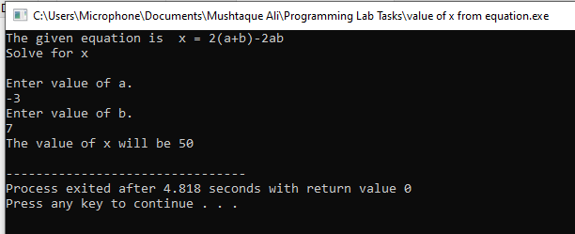

Activity: 07
7. Write a program for mark sheet, where user should be able to enter the marks for five
subjects. Then, your program should tell him/her his/her obtained marks and
percentage. Note: You can assume each subject to be of 100 marks. So the total marks
would become 500 for five subjects.

INPUT

#include <iostream>
using namespace std;
int main ()
{

int eng, ict, math, phy, prog;
float obtainm, per;

cout<<"Enter your English marks"<<endl;
cin>>eng;

cout<<"Enter your ICT marks"<<endl;
cin>>ict;

cout<<"Enter your math marks"<<endl;
cin>>math;

cout<<"Enter your physics marks"<<endl;
cin>>phy;

cout<<"Enter your programming marks"<<endl;
cin>>prog;

cout<<"\n";

obtainm=eng+ict+math+phy+prog;
cout<<"Your obtained marks are "<<obtainm;

cout<<"\n";

per=obtainm/500*100;
cout<<"Your percentage is "<<per<<endl;

return 0;
}

OUTPUT

